A SEMINAR REPORT

ON

“HOPE – BLOOD DONATION WEBSITE”

Submitted by

Nutan Arya

Harsh Naikwade

Yukta Lokwani

Apeksha Meharkar

Mehlam Ali

UNDER THE GUIDANCE OF

Prof. Ajita Mahapadi

Towards the partial fulfillment of Second Year under Graduate Course in Computer Engineering

Of

SAVITRIBAI PHULE UNIVERSITY OF PUNE

In the academic year 2021-22



DEPARTMENT OF COMPUTER ENGINEERING,

Dr. D. Y. Patil Educational Enterprises Charitable Trust’s

# Dr. D. Y. Patil School of Engineering

Dr. D. Y. Patil Knowledge City, Charholi (Bk), Lohegaon, Pune - 412 105

Affiliated to

SAVITRIBAI PHULE UNIVERSITY OF PUNE (2020-201)



DEPARTMENT OF COMPUTER ENGINEERING,

Dr. D. Y. Patil Educational Enterprises Charitable Trust’s

Dr. D. Y. Patil School of Engineering

Dr. D. Y. Patil Knowledge City, Charholi (Bk), Lohegaon, Pune - 412 105

# CERTIFICATE

This is to certify that Seminar Report

On

“HOPE – BLOOD DONATION WEBSITE”

Submitted by

Exam seat no:S190884211 Nutan Arya

Exam seat no:S190884249 Harsh Naikwade

Exam seat no:S190884281 Yukta Lokwani

Exam seat no:S190884210 Apeksha Meharkar

Exam seat no:S190884206 Mehlam Ali

Towards the partial fulfillment of Second Year under Graduate Course in

Computer Engineering

Of

SAVITRIBAI PHULE UNIVERSITY OF PUNE

In the academic year 2021-22

Prof. Ajita Mahapadi Dr. Pankaj Agarkar

**Seminar Guide** **HOD**

Dr. F B Sayyed

**Principal**

**ACKNOWLEDGEMENT**

It gives me a great pleasure and immense satisfaction to present this special topic Seminar report on “HOPE – BLOOD DONATION WEBSITE”

Which is the result of unwavering support, expert guidance and focused direction of my guide Prof. **Ajita Mahapadi** to whom I express my deep sense of gratitude and humble thanks, for his valuable guidance throughout the presentation work. The success of this Seminar-I has throughout depended upon an exact blend of hard work and unending co-operation and guidance, extended to me by the superiors at our college.

Furthermore, I am indebted to **Dr. Pankaj Agarkar,** HOD Computer and **Dr. F B Sayyed,** Principal whose constant encouragement and motivation inspired me to do my best.

Last but not the least I sincerely thanks to my colleagues, the staff and all others who directly or indirectly helped us and made numerous suggestions which have surely improved the quality of my work.

Nutan Arya

Harsh Naikwade

Yukta Lokwani

Apeksha Meharkar

Mehlam Ali

(S.E. Computer Engineering)

## INDEX

|  |  |  |
| --- | --- | --- |
| **NO.** | **CHAPTER NAME** | **PAGE NO.** |
| **ABSTRACT** | | **1** |
| **1** | **INTRODUCTION** | **2** |
| **2** | **MOTIVATION** |  |
| **3** | **LITERATURE SURVEY** |  |
| **4** | **SYSTEM ARCHITECTURE** |  |
| **5** | **ADVANTAGES AND DISADVANTAGES** |  |
|  | **5.1. ADVANTAGES** |  |
|  | **5.2. DISADVANTAGES** |  |
| **6** | **TECHNICAL STACK** |  |
| **7** | **APPLICATION** |  |
| **8** | **FUTURE SCOPE** |  |
| **9** | **CONCLUSION** |  |
| **REFERENCES** | |  |

**ABSTRACT**

To overcome the issue of deaths caused by not receiving blood on time due to shortage of blood in blood banks, Our Group has decided to build a web platform “**HOPE**” where the Hospital staff can login and make a request post with all the details regarding the blood which will send alerts to all the users within a given radius location. Our aim through this website is to not only provide blood to the person in need but also to create awareness among people about the “Need of Blood donation” and encourage them to donate blood as blood can’t be manufactured and more than 38,000 blood donations are needed every day. Requirement of blood for Transfusion Centers(TCs) and Hospitals has increased in past few years. Hence, it is essential to increase number of blood donors and maintain efficiency . To make sure that the blood isn’t misused only authorized hospitals will have the access to make request posts on our website

**CHAPTER 1**

**INTRODUCTION**

A human blood transfusion is a procedure of supplying a human body with adequate blood when needed as in cases of illness, accidents, diseases, surgery, etc. In the process, the blood obtained from the bodies of other voluntary healthy individuals is used to be supplied to the people who need it. The process generally takes around 60-180 minutes, varying on the amount of blood needed. To acquire the highest protection the requirements of good manufacturing practices and implementation of quality systems moving towards total quality management, have posed a challenge to the organization and management of blood transfusion service. Requirement of blood for Transfusion Centers(TCs) and Hospitals has increased in past few years. Hence, it is essential to increase number of blood donors and maintain efficiency.

In case of emergency, Transfusion Centers(TCs) and Hospitals need to contact nearest blood bank and search for the required blood or they have to organize blood donation campaigns which is time consuming and difficult task.

**‘Hope’** is a web-based application which will direct Transfusion Centers(TCs) and Hospitals to get blood from donors in case of emergency by posting required details and sending SMS (Short Message Service) alert to the registered donors.

**CHAPTER 2**

**MOTIVATION**

Basically , our main motive was to make a project which will actually decrease the number of deaths caused each year due to lack of blood supply to hospitals and also encourage people to donate blood and debunk the myths related with the procedure of blood transfusion.

The aim of creating “Hope - The blood donation website” was to provide a platform to fulfill the above motives!

**CHAPTER 3**

**LITERATURE SURVEY**

“Blood Donation Crisis in India” [1],by Varnika Srivastava it’s mentioned that India needs to increase the blood donors and it’s also stated that the misinformation regarding donating blood is the main reason behind the shortage of donors in India.

“Using Google Maps API for website development”[2], by Wojciech Zabierowski it’s stated that API can be used free of cost in websites.

“Blood donation management system ”[3],bySara A. Hashim, Afnan M. Al-Madani, Shatha M. Al-Amri, Abeer M. Al-Ghamdi, Bayan S. Bashamakh. Nahla Aljojo, PhD. They defined Blood donation management system as an information management system that contributes to the management of donor records and blood bank. Their system allowed an authorized hospitals and transfusion centers to sign in with a password and user id to manage easily the records of donors and patients who need blood. The purpose of this research was to find a way to implement a system that will provide a solution not only to hospitals but also to the numerous patients and willing blood donors.

**CHAPTER 4**

**SYSTEM ARCHITECTURE**

Architecture diagram explains how system works in real. There are four main components which are central database, users(donors and hospitals), server and Google Map API Services. The server will consist of database where data such as hospital and donors details, locations are stored at. Blood donation website will consist of the hospital login members and users like us who can register themselves and once registered, they become the donor member of our website. The website will be for the hospitals where they will be added by admin and the user_id and password will be given to the hospitals by the admin. Then the hospitals can post request for blood and also respond to users request. Users are able to see the location of hospital where blood is needed using internet through Google Map API. If donors want to donate blood they can simply accept the request posted by hospitals and register for donation. Server stores all the information and provide it to the given central database.

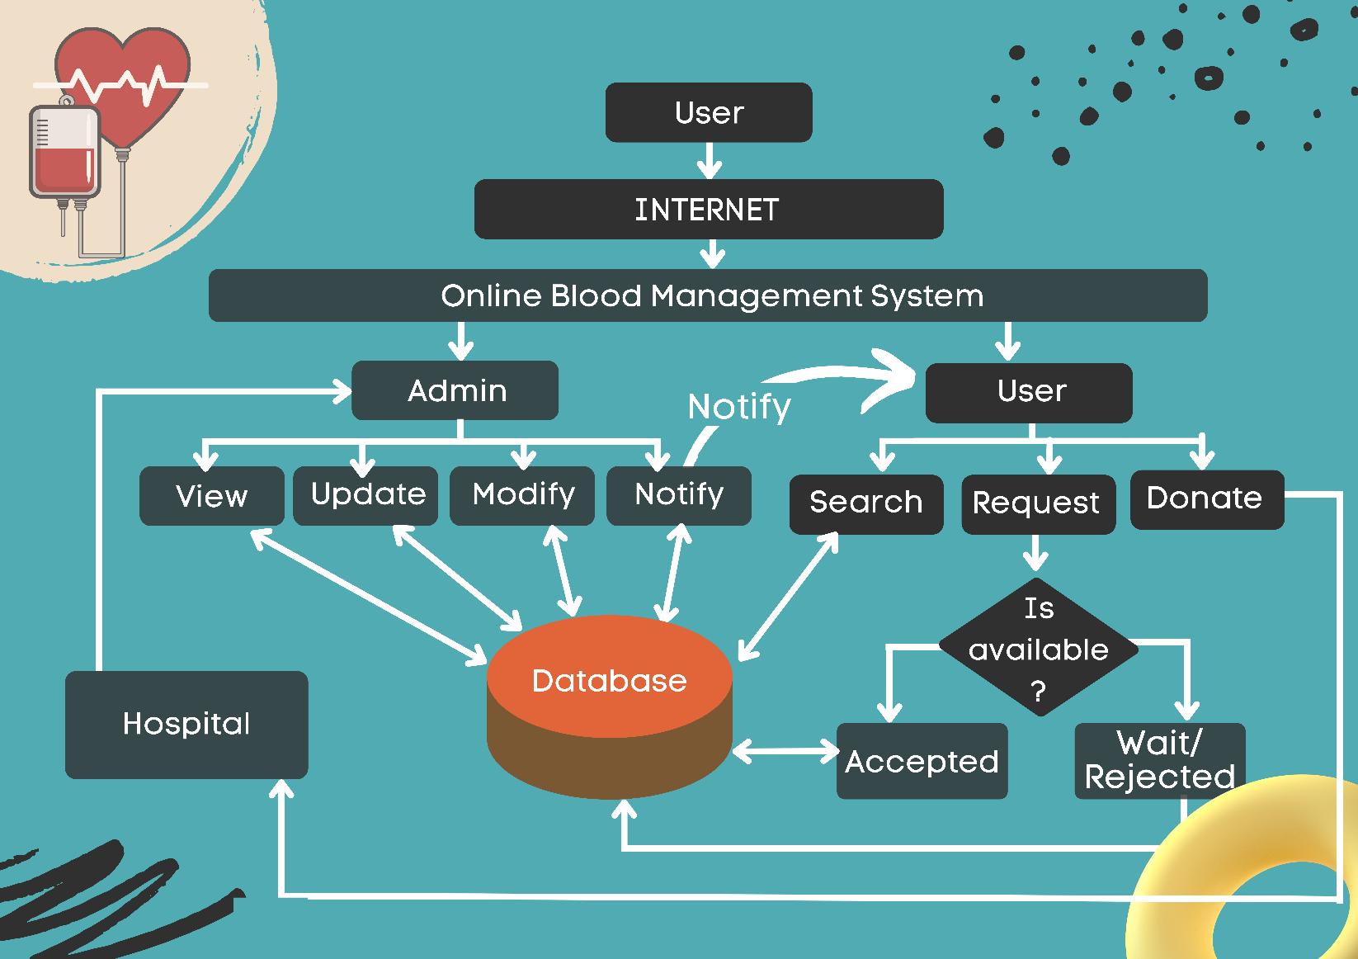**CHAPTER 4**

**ADVANTAGES :**

* Creates awareness about THE NEED to donate blood
* The post reaches the potential donors.
* Posts made by authorized hospitals only.
* Only donors within a given range can get SMS alert.
* Auto message generator.
* Debunks myths about blood donation.
* Security : Privacy of donors.
* Person verification
* One-to-One Interaction : Donors need to interact with just the officials for a private donation.
* User Profile: donor and hospital profiles will have different UI
* Provides an easy intermediate to donate blood amongst new generation.

**DISADVANTAGES :**

* Can’t send specialized alerts based on blood and donor type needed.

**CHAPTER 5**

**TECHNICAL STACK:**

Frontend 🡪 Html5 ,Css3, React, Js , Bootstrap.

Backend 🡪 Node.js.

Database 🡪 Mongo DB.

Additional 🡪 Google maps API.

**CHAPTER 6**

**APPLICATION :**

* Our website can also be used in camps as it asks for data to understand eligibility for donation.
* If during any checkup or treatment some infection or any such medical condition is detected then the concerned MP (medical practitioner) will update us and we will update our website accordingly.
* Used in hospitals in case of emergency especially in ER.
* Also, can be used as a platform to create awareness and debunk myths related to blood donation.

**CHAPTER 7**

**FUTURE SCOPE:**

* We can overcome the disadvantage by using AI and sending specialized alerts to different types of user donors.
* We also plan to make a mobile application for easier use by the donors.
* We also plan to make a different sector for other organizations can create blood camp promotional post on our website.
* We also plan on making a characterized UI based on the days left until the donor can donate blood again.

**CHAPTER 8**

**CONCLUSION :**

Hope – Blood Donation Website provides an easy, secure and provide 24/7 availability of fast services, within just a click of a button you can save lives.

**REFERENCES**

* Sara A. Hashim, Afnan M. Al-Madani, Shatha M. Al-Amri, Abeer M. Al-Ghamdi, Bayan S. Bashamakh. Nahla Aljojo, PhD,“Blood donation management system ”, Life Science Journal 2014;11(8).
* Wojciech Zabierowski ,“Using Google Maps API for website development”,reserchgate.
* Varnika Srivastava, “Blood Donation Crisis in India”,the logical Indian.
* Hisham S, Al-Madani A, Al-Amri A, Al-Ghamdi A, Bashamakh B, Aljojo N.,“Online Blood Donation Reservation And Managementsystem”, Life Sci J 2014;11(8):60-65]. (ISSN:1097-8135).